Rietveld analysis of the CuWO4 / CuSe hydrothermal series
Phase quantification, refined lattice parameters and structural model parameters from whole-pattern refinement of the raw diffraction data. Prepared 7 August 2026.

1. Data and method
Five patterns were refined: the CuWO4 starting material, the CuSe reference prepared hydrothermally, and the three intermediate products at nominal CuWO4 to CuSe ratios of 4:1, 1:1 and 1:4. Raw data were supplied as coupled scans from 10 to 90 degrees 2theta in 0.005 degree steps (10 to 80 degrees for CuWO4) and were rebinned to 0.02 degrees for refinement.
Refinement used a Rietveld formulation in which atomic coordinates, site occupancies and displacement parameters were held fixed at the published values for each phase, taken from the Crystallography Open Database. Refined quantities were a single sample zero shift, and for each phase the scale factor, the free lattice parameters permitted by its space group, two Caglioti width coefficients, the pseudo-Voigt mixing parameter, and for klockmannite a March-Dollase texture ratio about the c axis. Background was modelled with an eight-term Chebyshev polynomial. Both Cu K-alpha1 (1.540598 A) and K-alpha2 (1.544426 A) were included with an intensity ratio of 0.5. Peak intensities were weighted as one over the counting variance.
The cubic Cu2-xSe lattice parameter was restrained to the range 5.695 to 5.725 A. Left unrestrained it collapsed towards 5.63 A and absorbed misfit belonging to klockmannite, reaching an implausible 32 weight percent in the single-phase CuSe reference. The restraint range is the interval determined from the 4:1 and 1:1 samples, in which this phase gives well resolved and unoverlapped reflections. All other lattice parameters were free within two percent of their published values.
Weight fractions follow the standard Rietveld relation, in which the weight fraction of a phase is proportional to its scale factor multiplied by the unit-cell mass and the unit-cell volume. No internal standard was used, so the fractions are relative to the crystalline phases modelled and any amorphous content is not accounted for.
Because atomic coordinates were not refined, this is a constrained Rietveld refinement rather than a full structural determination. Releasing the two free klockmannite z coordinates was tested and rejected: it traded against the phase scale factors and drove the 1:4 sample to a visibly worse fit with a distorted umangite cell. The figures of merit should be read in that light.

2. Refinement figures of merit
Sample | Rwp (%) | Rp (%) | Rexp (%) | GOF | Zero shift (deg) | Parameters | Points
CuWO4 | 9.97 | 7.17 | 10.07 | 0.99 | +0.0019 | 19 | 3500
CuWO4-CuSe 4:1 | 9.66 | 7.41 | 9.48 | 1.02 | -0.0045 | 28 | 4000
CuWO4-CuSe 1:1 | 14.86 | 10.79 | 10.12 | 1.47 | +0.0102 | 35 | 4000
CuWO4-CuSe 1:4 | 25.37 | 19.70 | 10.16 | 2.50 | +0.0300 | 35 | 4000
CuSe | 32.97 | 27.27 | 11.19 | 2.95 | +0.0300 | 21 | 4000

The supplied intensities are normalised rather than raw counts, so the statistical weights and therefore Rexp and GOF are approximate. Rwp and Rp are the meaningful comparators between samples.

3. Phase quantification
Sample | CuWO4 | CuO tenorite | Cu3Se2 umangite | CuSe klockmannite | Cu2-xSe berzelianite
CuWO4 | 100.0 | - | - | - | -
CuWO4-CuSe 4:1 | - | 56.2 | 6.9 | - | 36.9
CuWO4-CuSe 1:1 | - | 7.3 | 46.2 | 34.8 | 11.7
CuWO4-CuSe 1:4 | - | 1.1 | 4.0 | 85.8 | 9.1
CuSe | - | - | - | 95.6 | 4.4

Values are weight percent of the crystalline phase assembly.
Reliability of each refinement
Sample | Status | Basis
CuWO4 | Quantitative | Single phase, GOF near unity, cell within 0.05 percent of the reference structure.
CuWO4-CuSe 4:1 | Quantitative | GOF near unity, flat difference curve, all three phases give well resolved reflections.
CuWO4-CuSe 1:1 | Semi-quantitative | Good overall fit, but the klockmannite fraction is inflated by the model deficiency described in section 8.
CuWO4-CuSe 1:4 | Indicative only | Dominated by klockmannite, whose published model does not reproduce the observed intensities. Fractions should not be quoted without a better CuSe structure.
CuSe | Model limited | Nearly single phase by peak inspection, yet Rwp remains high because the klockmannite model under-predicts its own low-angle reflections.

Comparison with the earlier estimate from the plotted figure
Sample | Phase | From digitised figure (wt%) | Rietveld (wt%) | Difference
CuWO4-CuSe 4:1 | CuO tenorite | 55 | 56.2 | +1.2
CuWO4-CuSe 4:1 | Cu3Se2 umangite | 6 | 6.9 | +0.9
CuWO4-CuSe 4:1 | Cu2-xSe berzelianite | 38 | 36.9 | -1.1
CuWO4-CuSe 1:1 | Cu3Se2 umangite | 79 | 46.2 | -32.8
CuWO4-CuSe 1:1 | Cu2-xSe berzelianite | 9 | 11.7 | +2.7
CuWO4-CuSe 1:1 | CuSe klockmannite | 6 | 34.8 | +28.8
CuWO4-CuSe 1:1 | CuO tenorite | 6 | 7.3 | +1.3
CuWO4-CuSe 1:4 | CuSe klockmannite | 65 | 85.8 | +20.8
CuWO4-CuSe 1:4 | Cu2-xSe berzelianite | 29 | 9.1 | -19.9
CuWO4-CuSe 1:4 | CuO tenorite | 5 | 1.1 | -3.9
CuWO4-CuSe 1:4 | Cu3Se2 umangite | 1 | 4.0 | +3.0
CuSe | CuSe klockmannite | 90 | 95.6 | +5.6
CuSe | Cu2-xSe berzelianite | 10 | 4.4 | -5.6

The two independent routes agree closely for the 4:1 sample and rank the phases identically everywhere. The largest divergences are in the klockmannite-bearing samples, consistent with the structural model limitation rather than with the digitisation.

4. Refined lattice parameters
Sample | Phase | Space group | a (A) | b (A) | c (A) | alpha (deg) | beta (deg) | gamma (deg) | V (A^3)
CuWO4 | CuWO4 | P-1 | 4.7079 | 5.8423 | 4.8816 | 91.653 | 92.534 | 82.756 | 133.03
CuWO4-CuSe 4:1 | CuO tenorite | C2/c | 4.6884 | 3.4249 | 5.1312 | 90.000 | 99.408 | 90.000 | 81.29
CuWO4-CuSe 4:1 | Cu3Se2 umangite | P-42_1m | 6.4036 | 6.4036 | 4.2784 | 90.000 | 90.000 | 90.000 | 175.44
CuWO4-CuSe 4:1 | Cu2-xSe berzelianite | Fm-3m | 5.7070 | 5.7070 | 5.7070 | 90.000 | 90.000 | 90.000 | 185.88
CuWO4-CuSe 1:1 | Cu3Se2 umangite | P-42_1m | 6.4043 | 6.4043 | 4.2798 | 90.000 | 90.000 | 90.000 | 175.54
CuWO4-CuSe 1:1 | Cu2-xSe berzelianite | Fm-3m | 5.7144 | 5.7144 | 5.7144 | 90.000 | 90.000 | 90.000 | 186.60
CuWO4-CuSe 1:1 | CuSe klockmannite | P6_3/mmc | 3.9448 | 3.9448 | 17.2619 | 90.000 | 90.000 | 120.000 | 232.63
CuWO4-CuSe 1:1 | CuO tenorite | C2/c | 4.6936 | 3.4235 | 5.1293 | 90.000 | 99.338 | 90.000 | 81.33
CuWO4-CuSe 1:4 | CuSe klockmannite | P6_3/mmc | 3.9483 | 3.9483 | 17.2646 | 90.000 | 90.000 | 120.000 | 233.07
CuWO4-CuSe 1:4 | Cu2-xSe berzelianite | Fm-3m | 5.6950 | 5.6950 | 5.6950 | 90.000 | 90.000 | 90.000 | 184.71
CuWO4-CuSe 1:4 | CuO tenorite | C2/c | 4.6922 | 3.4128 | 5.1507 | 90.000 | 99.391 | 90.000 | 81.38
CuWO4-CuSe 1:4 | Cu3Se2 umangite | P-42_1m | 6.3991 | 6.3991 | 4.2358 | 90.000 | 90.000 | 90.000 | 173.45
CuSe | CuSe klockmannite | P6_3/mmc | 3.9446 | 3.9446 | 17.2566 | 90.000 | 90.000 | 120.000 | 232.53
CuSe | Cu2-xSe berzelianite | Fm-3m | 5.6950 | 5.6950 | 5.6950 | 90.000 | 90.000 | 90.000 | 184.71

5. Profile and texture parameters
Sample | Phase | Caglioti U | Caglioti W | pseudo-Voigt eta | March-Dollase r
CuWO4 | CuWO4 | 0.0339 | 0.01509 | 0.783 | -
CuWO4-CuSe 4:1 | CuO tenorite | 0.5383 | 0.22780 | 0.663 | -
CuWO4-CuSe 4:1 | Cu3Se2 umangite | 0.1039 | 0.01338 | 0.986 | -
CuWO4-CuSe 4:1 | Cu2-xSe berzelianite | 0.4314 | 0.11279 | 1.000 | -
CuWO4-CuSe 1:1 | Cu3Se2 umangite | 0.0786 | 0.01061 | 0.765 | -
CuWO4-CuSe 1:1 | Cu2-xSe berzelianite | 0.0435 | 0.04787 | 0.999 | -
CuWO4-CuSe 1:1 | CuSe klockmannite | 0.5294 | 0.00003 | 0.994 | 1.289
CuWO4-CuSe 1:1 | CuO tenorite | 0.9060 | 0.16304 | 0.276 | -
CuWO4-CuSe 1:4 | CuSe klockmannite | 0.6865 | 0.00001 | 1.000 | 1.257
CuWO4-CuSe 1:4 | Cu2-xSe berzelianite | 0.2302 | 0.82047 | 0.000 | -
CuWO4-CuSe 1:4 | CuO tenorite | 1.0000 | 0.02282 | 0.000 | -
CuWO4-CuSe 1:4 | Cu3Se2 umangite | 1.0000 | 1.00000 | 1.000 | -
CuSe | CuSe klockmannite | 0.2769 | 0.00226 | 1.000 | 1.218
CuSe | Cu2-xSe berzelianite | 1.0000 | 1.00000 | 0.999 | -

The Caglioti coefficients give the squared full width at half maximum as U tan^2(theta) + W in degrees squared. A March-Dollase ratio below unity indicates plate-like crystallites with the c axis preferentially perpendicular to the plate.

6. Structural models used
Atomic coordinates were fixed at these published values throughout.
CuWO4, space group P-1, COD-4000809_CuWO4_triclinic_ambient_293K.cif
Atom | x | y | z | Occupancy | B (A^2)
W | 0.02117 | 0.17347 | 0.25421 | 1.000 | 0.300
Cu | 0.49530 | 0.66010 | 0.24530 | 1.000 | 0.490
O | 0.24900 | 0.35190 | 0.42390 | 1.000 | 0.529
O | 0.21620 | 0.88110 | 0.42760 | 1.000 | 0.387
O | 0.73620 | 0.38010 | 0.09700 | 1.000 | 0.458
O | 0.77900 | 0.90730 | 0.05020 | 1.000 | 0.632

CuO tenorite, space group C2/c, COD-9014580_CuO_tenorite_298K.cif
Atom | x | y | z | Occupancy | B (A^2)
Cu | 0.25000 | 0.25000 | 0.00000 | 1.000 | 1.000
O | 0.00000 | 0.41840 | 0.25000 | 1.000 | 1.000

Cu3Se2 umangite, space group P-42_1m, COD-9009856_Cu3Se2_umangite.cif
Atom | x | y | z | Occupancy | B (A^2)
Cu1 | 0.00000 | 0.00000 | 0.00000 | 1.000 | 2.300
Cu2 | 0.64700 | 0.85300 | 0.21900 | 1.000 | 2.300
Se | 0.27200 | 0.77200 | 0.26400 | 1.000 | 1.900

CuSe klockmannite, space group P6_3/mmc, COD-9000063_CuSe_klockmannite.cif
Atom | x | y | z | Occupancy | B (A^2)
Cu1 | 0.33333 | 0.66667 | 0.75000 | 1.000 | 1.000
Cu2 | 0.33333 | 0.66667 | 0.10700 | 1.000 | 1.000
Se1 | 0.33333 | 0.66667 | 0.25000 | 1.000 | 1.000
Se2 | 0.00000 | 0.00000 | 0.06600 | 1.000 | 1.000

Cu2-xSe berzelianite, space group Fm-3m, COD-9009855_Cu1.798Se_berzelianite.cif
Atom | x | y | z | Occupancy | B (A^2)
Cu1 | 0.25000 | 0.25000 | 0.25000 | 0.647 | 2.500
Cu2 | 0.33333 | 0.33333 | 0.33333 | 0.063 | 2.500
Se | 0.00000 | 0.00000 | 0.00000 | 1.000 | 2.000

7. Selenium to copper ratio implied by the phase fractions
Sample | Nominal CuWO4:CuSe | Se:Cu atomic ratio from refinement
CuWO4 | no Se | 0.00
CuWO4-CuSe 4:1 | 4:1 | 0.21
CuWO4-CuSe 1:1 | 1:1 | 0.68
CuWO4-CuSe 1:4 | 1:4 | 0.92
CuSe | CuSe only | 0.98

The ratio increases monotonically with the selenium loading of the synthesis, and the CuSe reference approaches unity. This is an internal consistency check on the phase assemblage, not an independent measurement. An EDX or ICP bulk Cu:Se ratio would test it directly.

8. Limitations
1. All atomic coordinates were held fixed at published values, so this is a constrained refinement and the quoted weight fractions inherit any error in the published structural models.
2. The dominant limitation is the klockmannite structural model. The idealised hexagonal P6_3/mmc average structure under-predicts the reflections near 26.1 and 26.6 degrees, indexed as (100) and (101). These are listed klockmannite spacings, and (100) is close to extinct in the averaged structure while being observed at roughly a fifth of the strongest peak. The phase-pure CuSe reference therefore refines to Rwp near 33 percent, which is poor for a single-phase sample, and the klockmannite weight fraction is inflated wherever the phase occurs.
Three routes to repair the model were tried and all were rejected. Releasing the two free z coordinates traded against the phase scale factors and drove the 1:4 sample to a worse fit with a distorted umangite cell. Releasing the four site occupancies against the phase-pure reference lowered Rwp from 33 to 29 percent only by driving the Cu1 occupancy to its lower bound, implying a composition of Cu0.57Se, which is not credible for klockmannite. Leaving the cubic Cu2-xSe cell free let that phase migrate to 5.63 A and absorb the misfit, reaching 32 weight percent in a sample whose pattern contains no berzelianite reflection at all. The misfit is therefore structural and real, and is most plausibly the orthorhombic Cmcm distortion of room-temperature klockmannite. No refined ambient Cmcm model could be obtained from the open databases.
The practical consequence is that the 1:4 and CuSe refinements should not be quoted as quantitative. Obtaining the ambient Cmcm klockmannite structure, for example from ICSD, and repeating the refinement would resolve this.
3. The cubic Cu2-xSe lattice parameter was restrained to 5.695 to 5.725 A. Left free it collapsed towards 5.63 A and absorbed the klockmannite misfit described above, reaching a physically implausible 32 weight percent in the single-phase CuSe reference. The restraint range is that determined from the 4:1 and 1:1 samples, where the phase gives well resolved and unoverlapped reflections.
4. No internal standard was used, so amorphous content is not quantified and all fractions are relative to the crystalline assemblage.
5. Microabsorption was not corrected. The selenides absorb Cu K-alpha more strongly than CuO, so their fractions may be slightly underestimated.

9. Rietveld fits
CuWO4
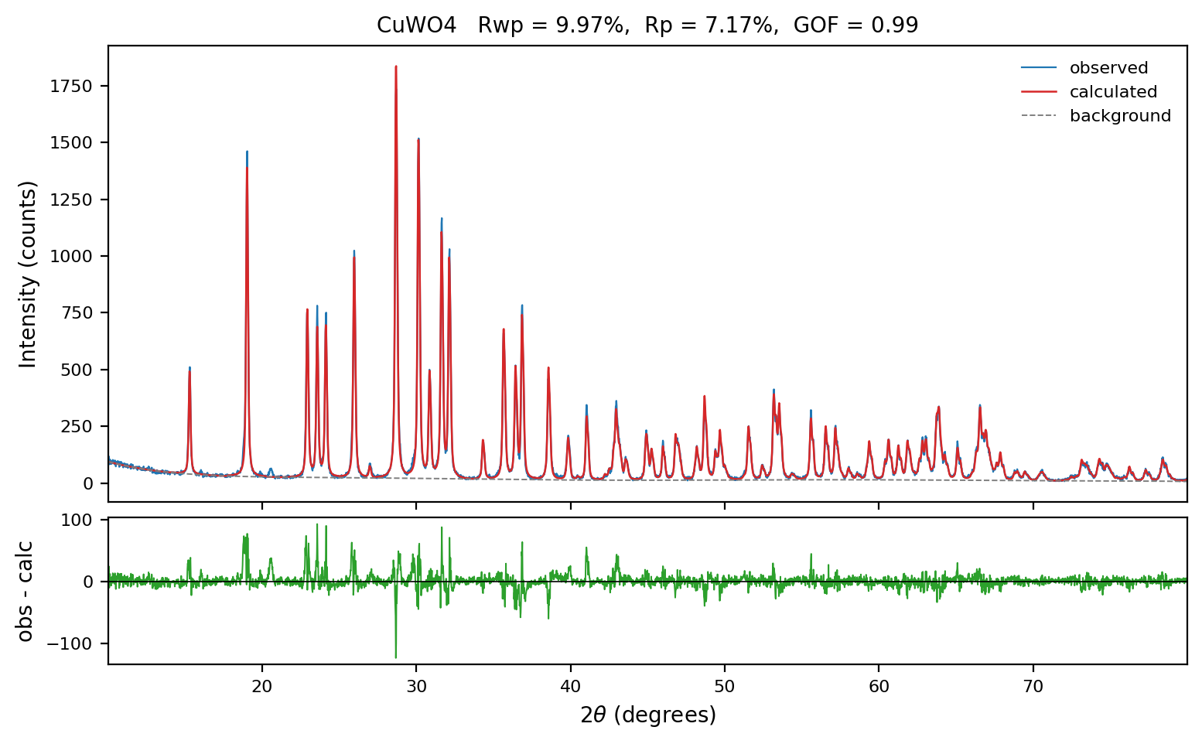
CuWO4-CuSe 4:1
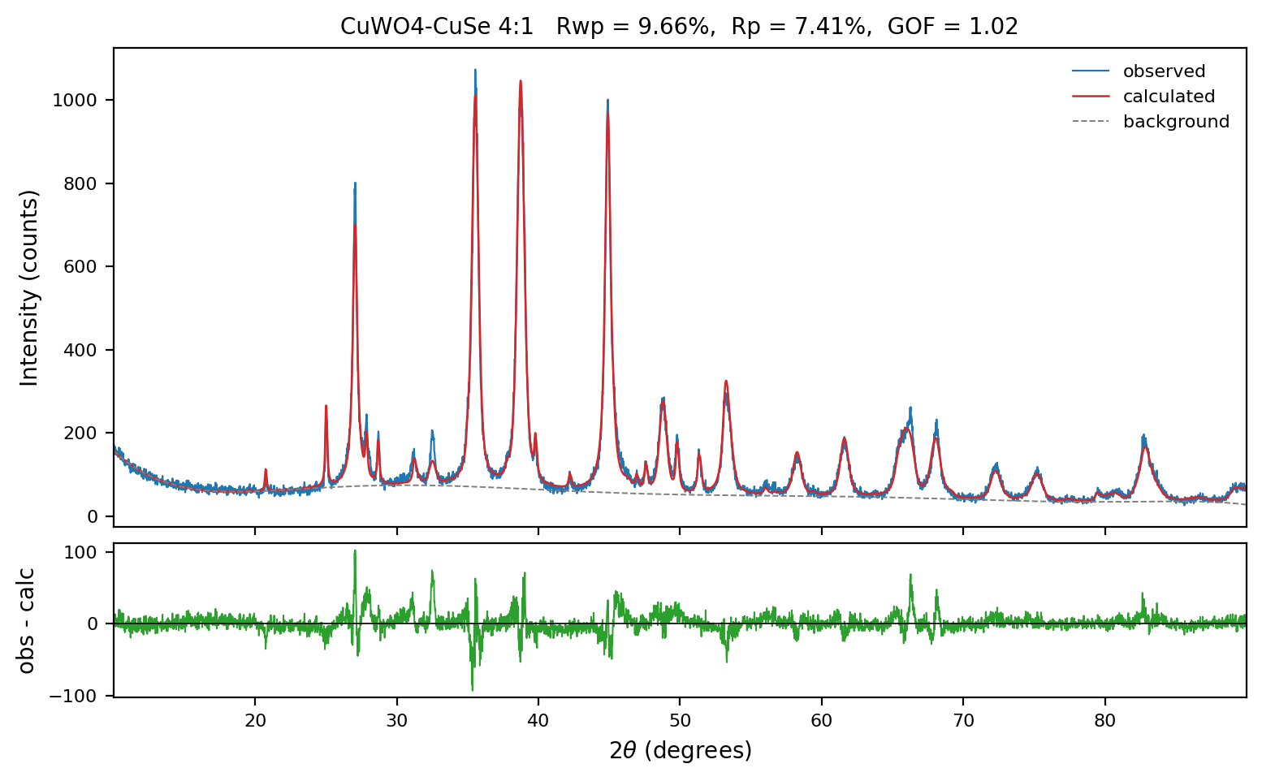
CuWO4-CuSe 1:1
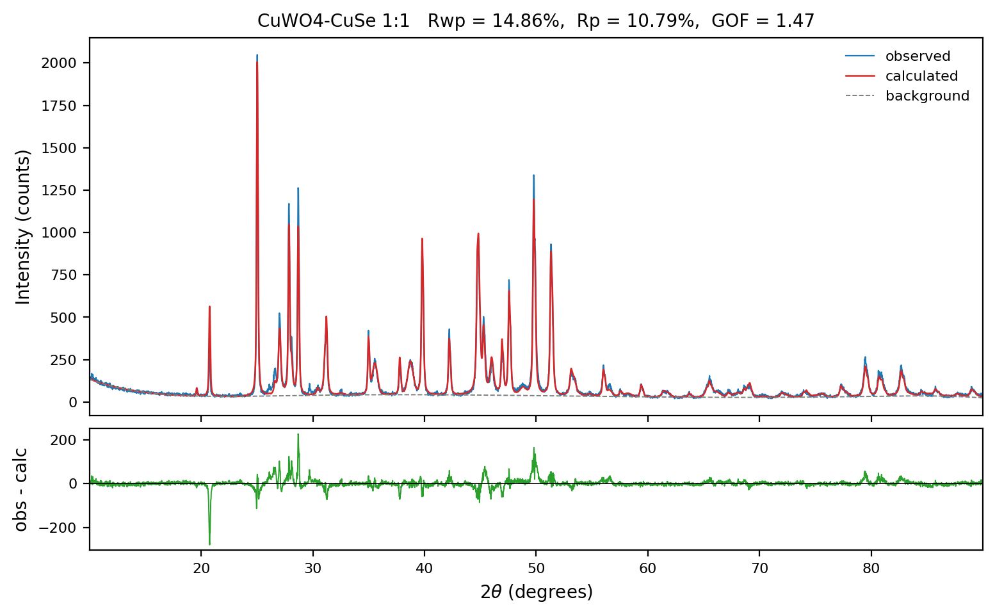
CuWO4-CuSe 1:4
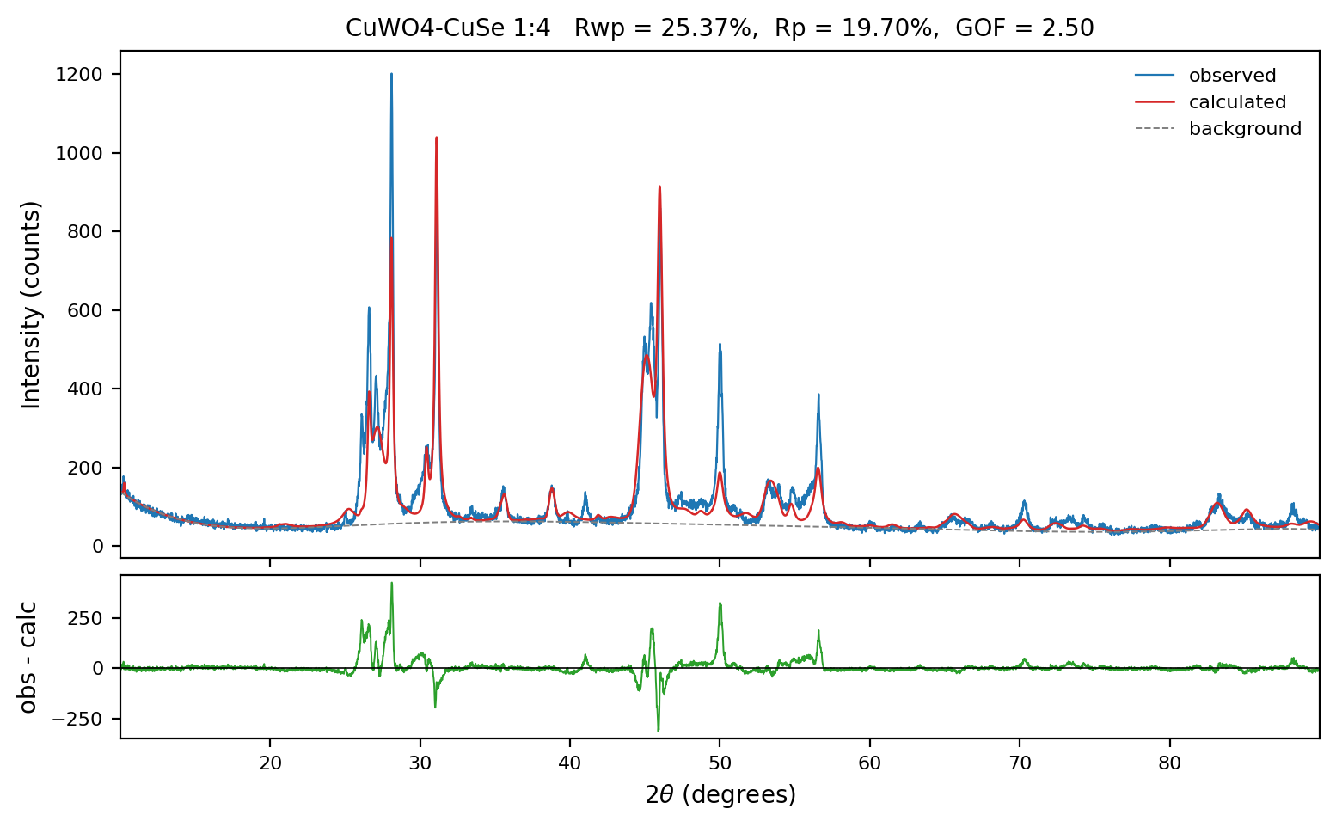
CuSe
